FOR IMMEDIATE RELEASE

LIGHT-HEARTED AND INSPIRING CONVERSATIONS TO DOMINATE *SCAPE’S FIRST VIRTUAL NATIONAL YOUTH FILM AWARD CONFERENCE
- The panel discussion on media scholarships with the Infocomm Media Development Authority (IMDA) is one of the key event highlights

06 April 2020, Singapore – With escalating news of the COVID-19 outbreak, Singaporeans can use a little bit of uplifting and inspiring conversations to get one’s mind off the crisis – if only for a moment. Hence, the annual National Youth Film Award (NYFA) Conference, organised by *SCAPE, is back!

Aligned with the theme for this year – “Emerging Trends and the Future of Content” – and also as a precautionary measure in view of COVID-19, the NYFA Conference will be going online for the first time. The conference will be screened live on 17 April 2020, from 1030 to 1900. Interested attendees can register here.

Among the list of prominent speakers are Dorcas Tan, Director (Human Capital Development) of the Infocomm Media Development Authority (IMDA), Doreen Neo, Chief Content Officer, Mediacorp, and Kenneth Goh, Executive Director, Association of Independent Producers Singapore (AIPRO).

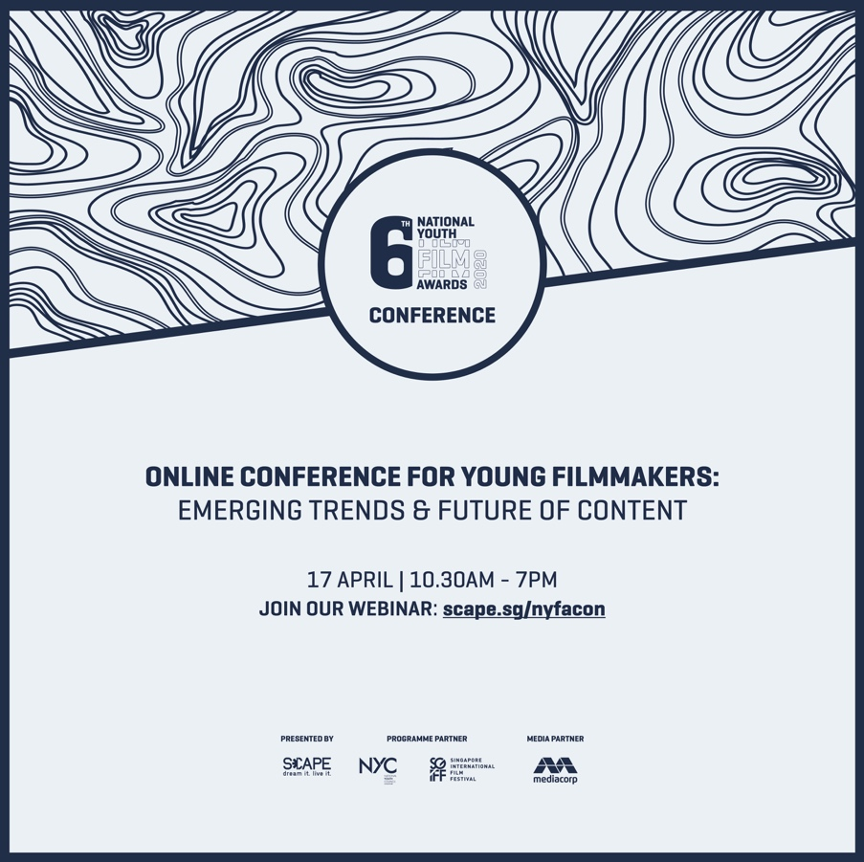
Media scholarships: Possibilities and Probabilities
One of the highly anticipated tracks of this year’s conference is “Media Scholarships: Possibilities and Probabilities” which will spotlight the opportunities available to Singaporeans keen to pursue further education in film overseas. Attendees can glean insights from past scholars – Low Ser En, Ivan Tan, and Jonathan Choo – as they share their meaningful journey from student to independent producer or director.

The Future of Content
As content creation and distribution continues to evolve, a key topic of interest for content creators is “Stories for The People by The People”. The panel discussion will see representatives from Wattpad, Singapore Book Council, Screenwriters Association of Singapore, and Mediacorp, explore the role of crowdsourcing and what it means for screenwriters and filmmakers who want to tell their own stories. It will also address how audiences are now active in creating and deciding what they want to watch in terms of screen entertainment.

Another interesting conversation to look out for is “Crystal-Balling the next wave: Trendspotting”. The panellists from DDB, Viddsee, Mediacorp, and Association of Independent Producers Singapore will share their current observation of the local and international film industry in terms of production practices. They will also give their take on emerging trends and highlight potential opportunities and challenges that come with these changes.

Nurturing and inspiring the next generation of filmmakers
The conference will conclude with a focus on NYFA’s past award winners, and the nation’s young filmmakers who have gone onto international stages with their short films and craft. Participants will be able to hear first-hand from Shoki Lin, Jerrold Chong, Tan Wei Ting, and Jonathan Choo, on how a quality short film can open doors internationally, and their international award exposure. Participants can also catch their winning films:

- ‘Adam’ by Shoki Lin
- ‘Piece of Meat’ by Jerrold Chong
- ‘Cash’ by Tan Wei Ting
- ‘Han’ by Jonathan Choo

The links to access these films will be shared during the conference.

At the end of each session, participants will have the opportunity to ask questions via the conference chat function. Participants can also email their questions to nyfa@scape.sg ahead of the conference.

The full conference agenda can be found in ANNEX A.

For media enquiries, please contact:
SG Story for *SCAPE
Rachelle Tan / Debbie Song
9011 0055 / 8360 9705
scapepr@sgstory.com

About *SCAPE
*SCAPE Co. Ltd is a non-profit organisation with its mission and vision rooted in support of youth, talent and leadership development. The organisation aims to facilitate youth-oriented programmes and support within various communities of youth interest in Singapore. The youth of today will be inspired and empowered to DREAM IT AND LIVE IT at *SCAPE!

*SCAPE exists to serve and support youths to live their dreams and realise their full potentials. As the integrated talent and resource hub for young people in Singapore, *SCAPE offers a holistic network of programmes, communities, partners and facilities for youths to explore, create and strive. No dream is too small, no dream is too big. *SCAPE wants youths to be inspired to come forward and share their interests, share their dreams. Through guidance and facilitation, *SCAPE wants to see their dreams turn into ideas, and ideas into reality. Living their dreams should no longer be a dream at *SCAPE.

@scapesg #scapesg www.scape.sg

About National Youth Film Awards
Since its inception in 2015, NYFA has been cultivating a community of like-minded media enthusiasts and is the connecting point for youths to network and collaborate.

Through NYFA, some of our alumni have been commissioned for various video
campaigns by corporate and industry partners such as Adobe, PAVE and SONY.

Together with industry partners, veterans, and institutes of higher learning, the NYFA programme is designed to spark deeper conversations amongst like-minded individuals and hone their crafts in filmmaking. NYFA supports artistic works from both aspiring and professional filmmakers and is committed to nurture the aspiration, vision, and creative spirit of these youths.

ANNEX A: AGENDA

Time | Agenda
1030 - 1130 | Stories by the People for the People  Crowd-sourcing started as a trend induced through the internet and has become a norm for knowledge sharing and decision-making. It has since evolved into directing and dictating major decisions satisfying consumer appetites. In Singapore, Mediacorp is partnering with Wattpad to adapt Wattpad’s hit romantic story “Slow Dancing” by Singaporean writer Noelle (@Hepburnettes) as a six-part series. “Slow Dancing” has garnered over 9.5 million reads to date and nearly 400,000 votes from fans.  With crowd-sourcing used for commercial such as content production, join the panel as they discuss how data drives decisions in storytelling if this is a way forward or has this been the norm all along and how writers and filmmakers should navigate in this evolving landscape.  Panellists:  - Dexter Ong, Head of Asia, Wattpad  - Kane Wheatley-Holder, Vice President, Screenwriters Association (Singapore)  - Kevin Ho, Assistant Lead, English Audience, Mediacorp  - William Phuan, Executive Director, Singapore Book Council

Time | Agenda
1200 - 1300 | Crystal-Balling the next wave: Trendspotting Content  In this joint effort, we will hear from key industry organisations who are in the content sphere developing, commissioning and owning media content. Together we will hope to scope out a list some key trends impacting content from creation to consumption.  From a youth perspective, this crystal-balling session would be insightful to the paths trodden and roads opened from predecessors. Will young filmmakers break traditions to ride trends or future-scape their paths using age known tactics?  Panellists:  - Doreen Neo, Chief Content Officer, Mediacorp  - Josiah Ng, Head of Film and Social Content, DDB  - Kenny Tan, Executive Producer – Head of Studios, Viddsee  - Kenneth Goh, Executive Director, Association of Independent Producers Singapore (AIPRO)
1400 - 1500 | Media Scholarships: Possibilities & Probabilities  Each year, under the Singapore Digital (SG:D) Scholarship, selected students are sent out to study and read subjects across the media and film education. With IMDA and some returning scholars, this session intends to shed light on the application process and perhaps share some tips and tricks towards being selected.  Panellists:  - Dorcas Tan, Director (Human Capital Development), IMDA  - Ivan Tan, Writer-Director (MES Scholar)  - Jonathan Choo, Director (MES Scholar)  - Low Ser En, Independent Producer (MES Scholar)

Time | Agenda
1600 - 1700 | Getting the right screens for your short film  A completed film is the end of the beginning. What lies beyond the film is a new life to navigate and find the best places to screen it and get recognized. In this session, we speak to a variety of film programmers to help you plan your festival strategy.  The panel will share some tips on film programming and the festival circuit, relating to experiences in selection, packaging and targeting the correct audience for your films. Rather than promote a one-size-fits-all short film, which is rare, discussions will be about how filmmakers can begin considering their target audience and eventual destinations before they submit their short films.  Panellists:  - Huang Ruilin, Consultant, Honour SG  - Ming-Jung Kuo, Programming Director, SGIFF  - Nikki Loke, Digital Content Lead, Viddsee  - Prashant Somosundram, General Manager, The Projector
1800 - 1900 | Young Filmmakers Going International  In recent years, there has been an increasing number of young local filmmakers who have been recognised on international stages. In this session, we will chat with past NYFA winners and Singapore filmmakers who have gone international with their works. They will share their experience of showcasing their stories to a foreign audience.  Panellists:  - Jerrold Chong, director, ‘Piece of Meat’  - Jonathan Choo, director, ‘Han’  - Tan Wei Ting, director, ‘Cash’  - Shoki Lin, director, ‘Adam’

