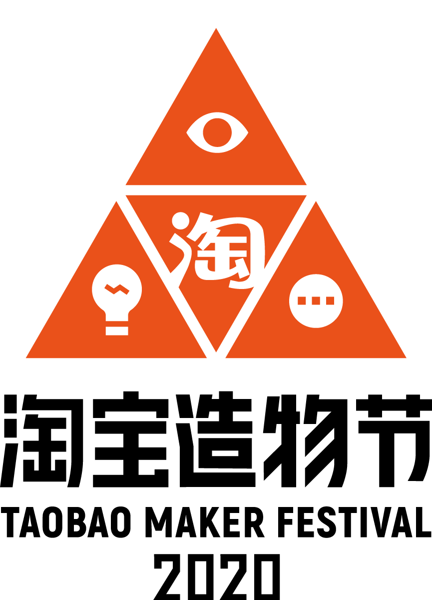

FOR IMMEDIATE RELEASE

Taobao Introduces Maker Rating System to Champion Young Entrepreneurs, Originality
New hybrid online-offline virtual experience on fifth anniversary

Hangzhou, China, July 30, 2020 –Taobao, China’s largest social commerce platform, today launched a new rating system that rewards outstanding young creators and small businesses with greater market exposure by spotlighting their creativity and making their products more accessible to over 840 million China retail marketplaces users. This launch coincides with the fifth anniversary of Taobao Maker Festival (TMF).

Started in 2016, TMF is Taobao’s signature event and this year it will take on a fresh approach that combines virtual exhibition together with a merchant road trip to engage with local fan communities in four cities – Hangzhou, Xi’an, Chengdu, and Wuhan.

Year-long support to merchants with more exposure
Taobao has upgraded the popular TMF awards into a rating system that will provide year-long brand exposure and marketing resources to China’s most talented and entrepreneurial young minds.

An independent panel of judges comprised of industry experts will review and rate all the TMF merchants that have participated over the past five years. The four-tiered rating system will reward digital badges to approximately 200 merchants. Products from the rated merchants will be included in the personalized product recommendation feature “Good Find” section on Taobao, which will significantly boost their profile and visibility to consumers.

“The new rating system promotes and celebrates originality and creativity. It will enable merchants to leverage their participation in the Taobao Maker Festival into a source of year-round benefit for growing their business and customers,” said Chris Tung, Chief Marketing Officer of Alibaba Group. “This is an initiative driven by our longstanding goal of helping small businesses and young makers to achieve their dreams and find success.”

Taobao’s Pioneering Content-Driven Commerce Strategy
The new rating system is the latest showcase of Taobao’s pioneering content-driven commerce strategy that was launched back in 2016, the year when the TMF was born. The strategy helped Taobao to transform from a transactional-driven e-commerce marketplace into a multi-dimensional social commerce platform that allows users to enjoy a wide range of content to drive sales efficiency and customer stickiness. Other flagship tools benefiting from the strategy include Taobao Live, Weitao (a social media platform on Taobao), short-form video, microblogs and the curated recommendation channel “Good Find.”

As a result of the strategy, Taobao has seen a major boost in the number of creative merchants, which now counts more than 200,000, representing a 200% growth from 2018.

Kaifu Zhang, Head of Taobao Operations, emphasized Taobao’s commitment to fostering China’s next generation of makers and merchants through content creation. “We continue to leverage our unique content-driven strength to help young entrepreneurs and small businesses win market traction and bringing better experience to consumers.”

First-ever TMF Road Show
Focusing on the positive impact of “New Blood,” TMF is making an innovation this year. For four days starting August 10, Taobao will launch its online exhibition, supported by Taobao Life, a 3D avatar-based virtual world. Taobao users can visit a six-themed online pavilion using their own unique avatar, interacting with the virtual figures of celebrities.

Another first this year is that TMF visitors do not need to come to the carnival. Instead, the carnival will come to them. The merchants will be out and about meeting TMF fans while on road trip to four cities: Hangzhou, Chengdu, Xi’an and Wuhan.

During the 20-day road trip, which starts in Hangzhou today, a large truck will be converted into mobile storefronts to allow dozens of merchants to display their products in each city. At each stop, Taobao and selected makers will also hold mini offline events that draw on each city’s unique culture and heritage.

Taobao Maker Festival to make its debut in Singapore
Local Edition to Include Taobao Merchant Collaborations with Singaporean Youth
Building on the success of the annual offline event, Taobao will also be bringing TMF to Singapore for the first time, from 7 to 13 August. This will be done in partnership with *SCAPE Singapore and the National Youth Council, as part of TMF’s overarching aim to empower youths and entrepreneurs and encourage them to pursue their creative aspirations and careers.

The festival will feature two collaborations to highlight local Singaporean youths in their element as innovators and trailblazers. Both collaborations will entail participants using either Taobao Maker products or working with an existing Taobao Maker to incorporate their own twist to showcase TMF products. These exciting collaborations will also be viewable via the Taobao app as well as various Taobao’s media channels.

With innovation as a key pillar of TMF, one of the collaborations will involve an AI Skateboard Showcase, where a local skateboarder will be invited to do a short film demonstrating how to artfully navigate a patented AI Skateboard from Taobao at *SCAPE’s very own skateboard park.

The second collaboration piece will aim to spotlight the blending of Chinese traditional culture and Singapore’s rich heritage through the partnership of a Chinese qipao designer, 金文聪 (Jīn Wén Cōng) and a Singaporean photographer. The two will be working together to conduct a photoshoot of the qipao designs modelled against the backdrop of a smattering of renowned Singapore landmarks.

“Celebrating innovation and uplifting our youth of today are the keystones of the Taobao Maker Festival. Singapore has a melting pot of diverse cultures and young individuals who are eager to break creative barriers, make their own mark, and showcase their creativity to the world, and this resonates deeply with TMF’s values. Through TMF’s Singapore debut, we hope to continue our efforts to showcase the millennial generation’s unique creativity and provide a solid platform for them to do so,” said Miko Tse, Marketing Manager, Taobao Singapore.

# # #

About Taobao Marketplace
Launched in 2003, Taobao Marketplace (www.taobao.com) provides consumers from both large cities and less developed areas with an engaging, personalized shopping experience, optimized by big-data analytics and technology. Through highly relevant and engaging content and real-time updates from merchants, consumers can learn about products and new trends. They can also interact with each other and their favorite merchants and key opinion leaders. Merchants on Taobao Marketplace are primarily individuals and small businesses. According to Analysys, Taobao Marketplace was China’s largest mobile commerce destination with a large and growing social community, in terms of GMV for the 12 months ended March 31, 2020. Taobao Marketplace is a business of Alibaba Group.

Media Contacts
Jenny Hsu | Claire Zhao
Alibaba Group | Alibaba Group
+86 178 5741 1742 | +852 9727 8923
jennyhsu@alibaba-inc.com | yanan.z@alibaba-inc.com

